LAB ASSIGNMENT-05 OUTPUTS

Question 01:

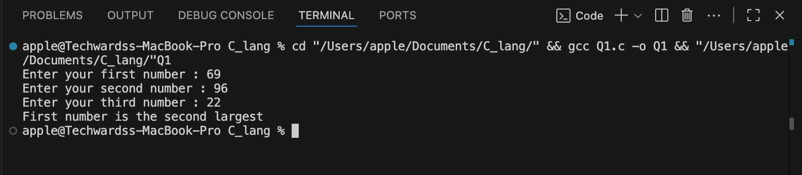

Question 02:

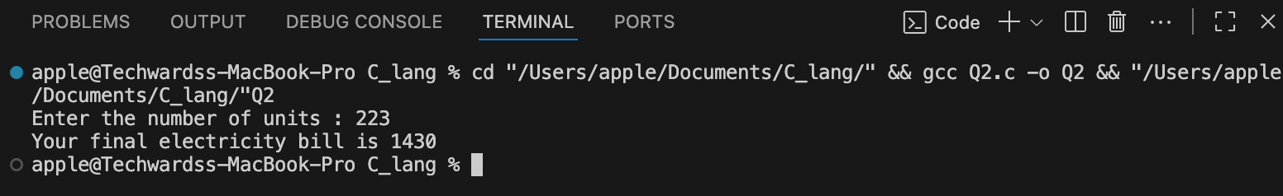

Question 03:

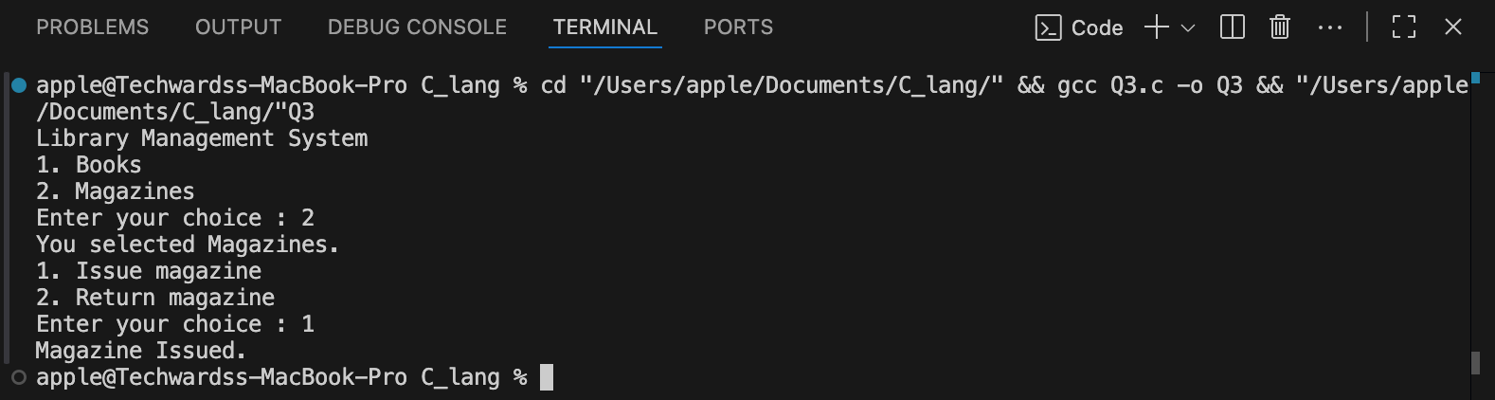

Question 04:
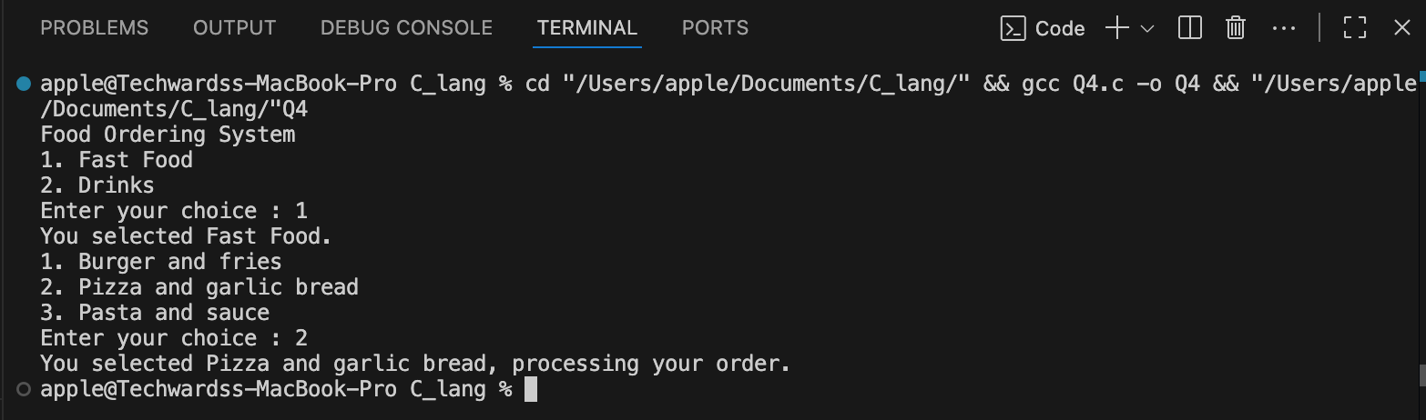

Question 05:

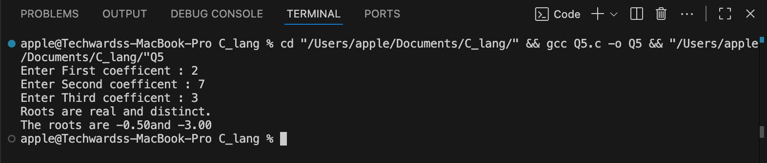

Question 06:

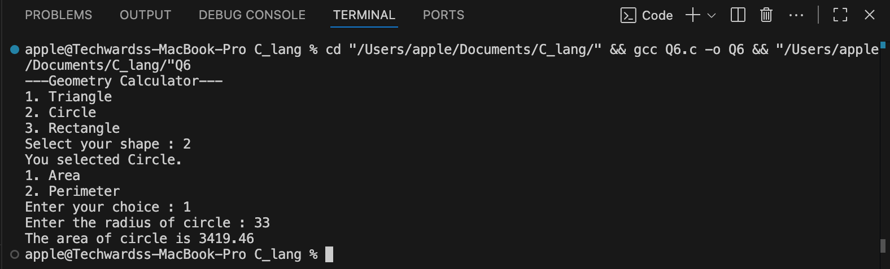

Question 07:

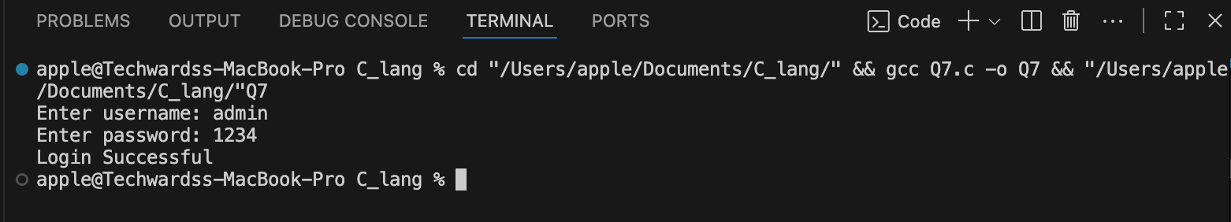

Question 08:

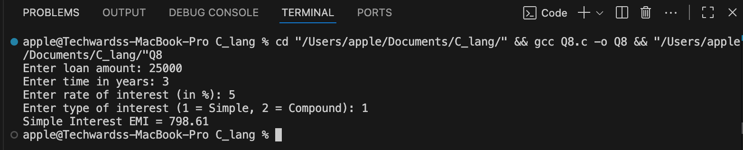

Question 09:

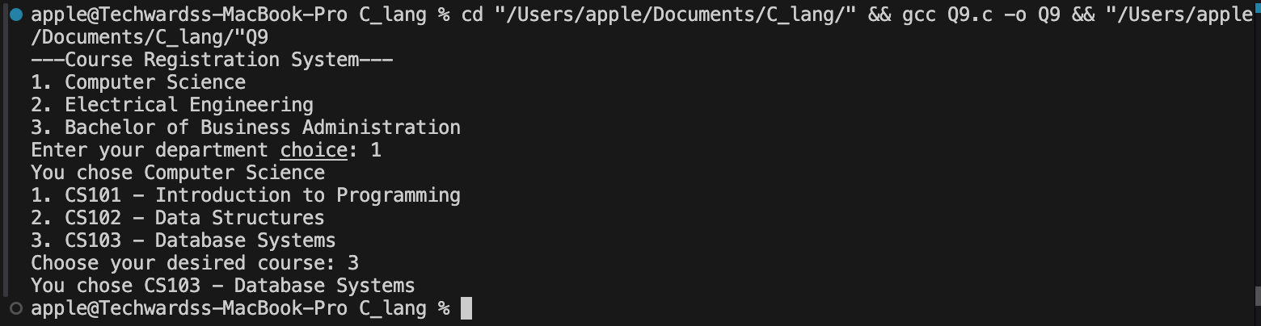

Question 10:

